GENERALIZED ERROR BUDGET APPLICATION FOR PROPAGATING ERROR AND APPLYING COMPENSATORS IN COMPLEX SYSTEMS

Tyler Seawright
M.S. Mechanical Engineering
San Jose State University

ERROR BUDGETS AND WHY THEY ARE FEARED
Error budgets are one of the last requests the typical engineer wants to hear and for good reason. We associate “budget” with not having enough or having to decide what to do with a scarce resource. However, without a good error budget, machine performance is impossible to guarantee.

Engineers design incredibly complex systems and with each, it is common to create an entirely new error budget. There is an ocean of details needed to model basic cases and the old method of using Excel spreadsheets is tedious to set up, unstable, and completely unflexible.

ERROR BUDGET DEFINITION
Error budgets apportion a total error to identified sources to drive design decisions. A good error budget identifies the sources the system is most sensitive to.

ABSTRACT PURPOSE
This abstract is intended to serve as a description of an open-source error budget application that includes a workflow to model complex systems with minimal setup time. In this abstract, a case study will be presented highlighting the capabilities. Error propagation methods used are HTM extracted from [1] and a new method for capturing coupled errors propagated from utilizing compensators. A built-in Montecarlo determines the average plus N-sigma error. This application does not focus on distinguishing types of error sources other than mechanical, but they are easily included if a sensitivity is provided.

ERROR BUDGET WORKFLOW
DEVELOP MATH MODEL
The math model represents the connection between parts of the error budget. This may include multiple vector paths that are stacked, definition of compensators, and sensitivities within the system. In the script, the math model is written as a comment in the header before implementing into the main function.
INPUT VECTOR LOOPS, ERROR TERMS, AND COMPENSATORS
In a screenshot, a sketch of the vector path to each part interface is helpful to organize the model. FIGURE 1 depicts the vector path with the CAD stripped away and the excel spreadsheet representing the inputs.
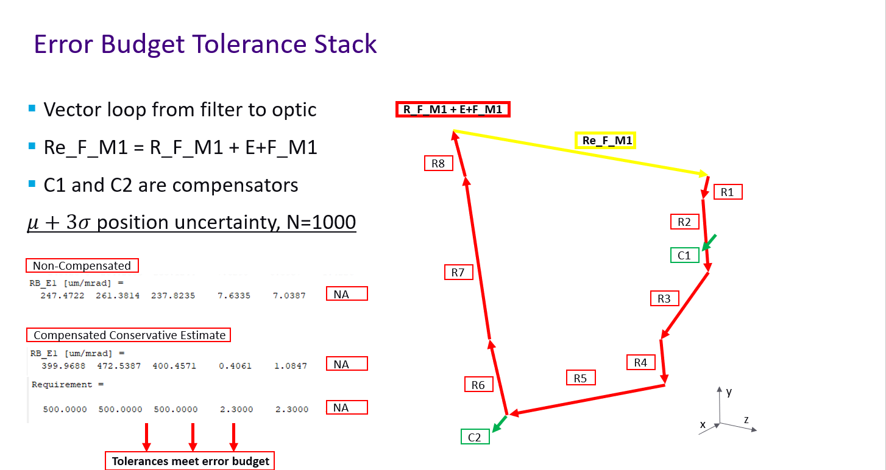
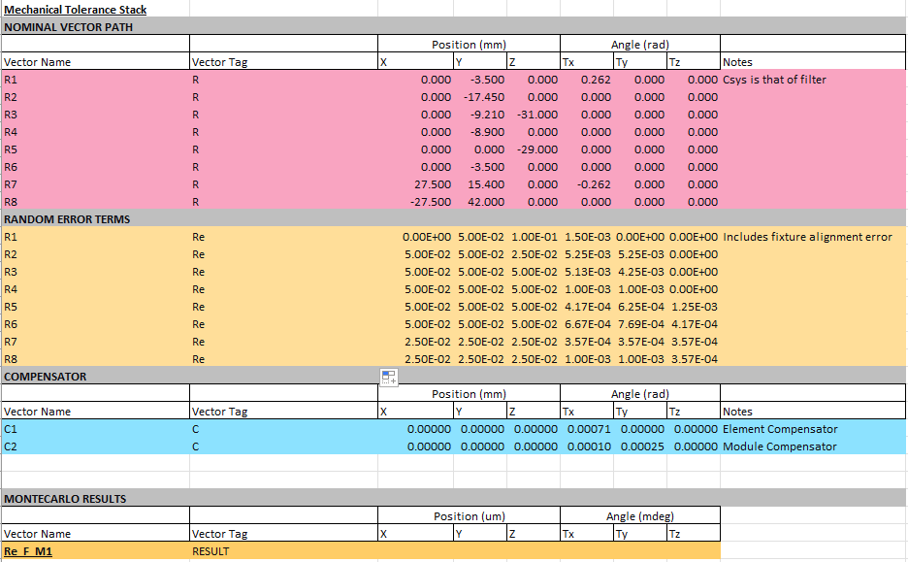
FIGURE 1. Math model for tolerance analysis used in case study.

The model is input into a spreadsheet as a list of 6 DOF vectors and relative errors. Since errors are relative, they may be input as the part tolerances as they are local to the part coordinate system. Each type of input is tagged to make the spreadsheet dynamic for MATLAB to parse as it becomes complex.

Compensators A compensator must be defined with a vector from the compensator to a point of interest and must contain a vector describing the resolution of the compensator per axis of compensation.

REVIEW RESULTS
Results are placed in the spreadsheet where specified. The script is fully customizable and works well as a function for building complex systems. The script prints results, plots histograms, and has a function for visualizing error and directions using plots of coordinate systems depicted in FIGURE 2
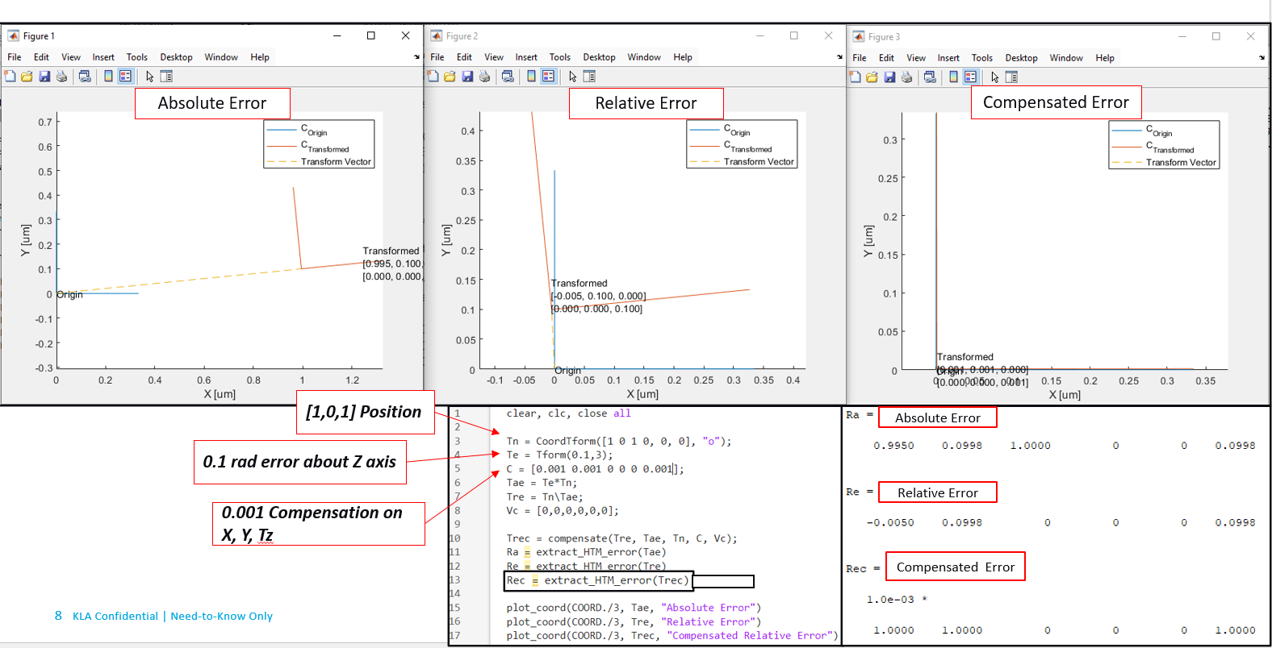
FIGURE 2. Visualization of coordinate transform error.

ERROR MODEL
VECTOR LOOP ERRORS USING HTM
The relative error between two points in six degrees of freedom is calculated by performing an inverse matrix multiplication of the nominal and errored absolute HTMs representing vector paths between two coordinate systems. Eq. 1 solves the nominal vector transform, Eq. 2 solves the absolute errored transform, and Eq. 3 solves the relative error transform in 6 DOF between the points of interest modeled by a coordinate system.
$T_{0}^{n}=T_{0}^{1}*T_{1}^{2}*…*T_{n-1}^{n}$ (eq. 1)
${Te}_{0}^{n}=E_{0}^{1}T_{0}^{1}*E_{1}^{2}T_{1}^{2}*…*{E_{n-1}^{n}T}_{n-1}^{n}$(eq. 2)
${Re}_{0}^{n}=T_{0}^{n}\backslash {Te}_{0}^{n}$ (eq. 3)

COMPENSATOR ERROR PROPAGATION
Compensators pose a challenge in precision engineering because when they are used, there may be coupled motion, which is difficult to quantify for random system error. The coupled motion to move the system from an arbitrary position to the compensated position is applied.

The compensator is applied by solving the compensator difference matrix which is the HTM representing how far the point of interest is from the compensator on the axes of compensation. The inverse compensator difference transform is then applied the compensator vector to point of interest and then to the absolute position HTM to rotate to the compensated position and propagate the parasitic rotation to the coupled axes. The steps are described in FIGURE 3.

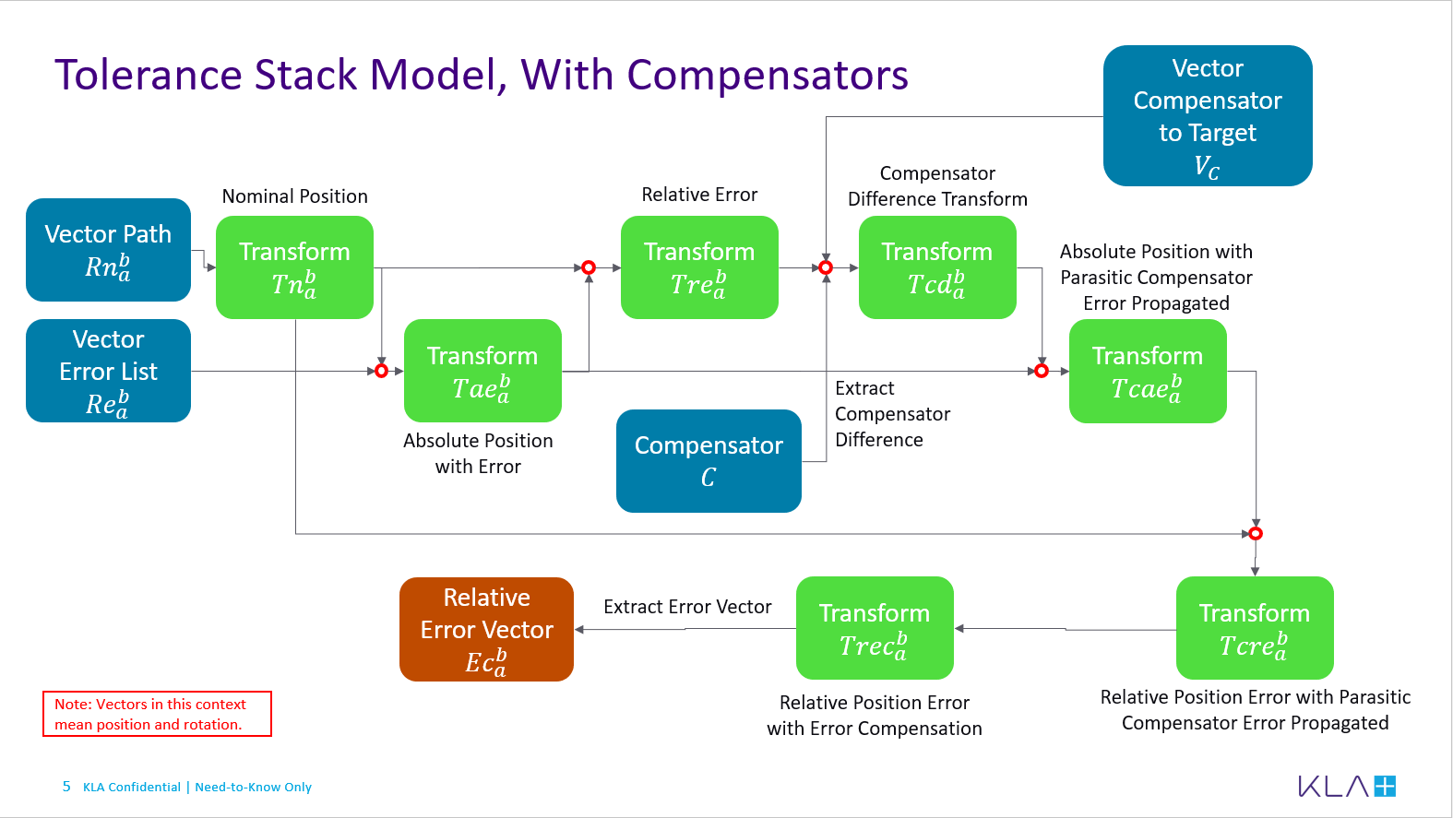
FIGURE 3. Flowchart applying compensators to solve relative error at a point of interest.

MODEL VALIDATION
The model was validated by testing a few cases in which an error was applied to a vector and then compensated in 3D and compared to manually calculated tolerance stacks.

CASE STUDY: OPTICAL ALIGNMENT
SYSTEM OVERVIEW AND REQUIREMENTS
The system is a prism actuated into and out of a beam in which the angle of the prism front surface with respect to the beam is critical. An optical sensitivity is provided to model the beam difference in beam position at a target which drives the angle requirement of 40mdeg from normal. Given the beam is 2.2mm diameter and clear aperture (CA) of the optic is 3.2mm, the required angle compensator adjustment must keep the beam within the CA. Because of a nearby beam, a shift in Z by 1mm causes clipping. TABLE 1. outlines the requirements. The beam position also includes uncertainties.

Requirement | Value | Unit
Prism Centration (x,y,z) | 0.5  0.5  1.0 | mm  mm  mm
Prism Orientation (Tx, Ty, Tz) | 2.3  2.3  20 | mrad  mrad  mrad
TABLE 1. Requirement table. All requirements are relative to previous optic in beam path.

ERROR MODEL
To be added in Long-Abstract

MODEL OUTPUTS
To be added in Long-Abstract

CONCLUSION
To be added in Long-Abstract

REFERENCES
- A. H. Slocum, Precision Machine Design. Prentice-Hall, Inc., 1992.

